**Part 1**

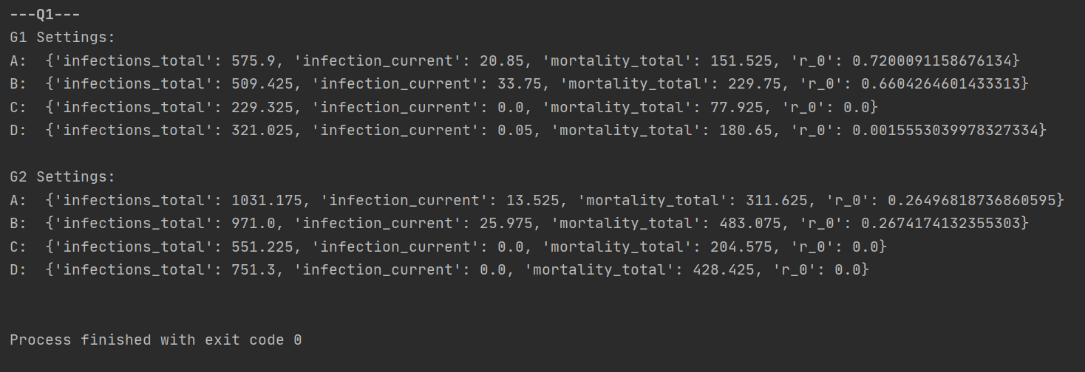**B. Average of 40 simulations**

* When we look on the aspect of which model type, we can see that in ‘SIR’ model, the infection gone fast. Because, people recover after they ill and can’t get the infection again.
* When we change the probability of an infectious and the infection time, we can see that when those settings get bigger the epidemic will be more contagious and the R_0 will be bigger. In the other hand, while people’s infection_time get bigger they have higher probability to die. That’s why we can see on setting B and D higher mortality_total. More mortality means that will be less infections in the future.

**Part 2**

**B. Average of 40 simulations**

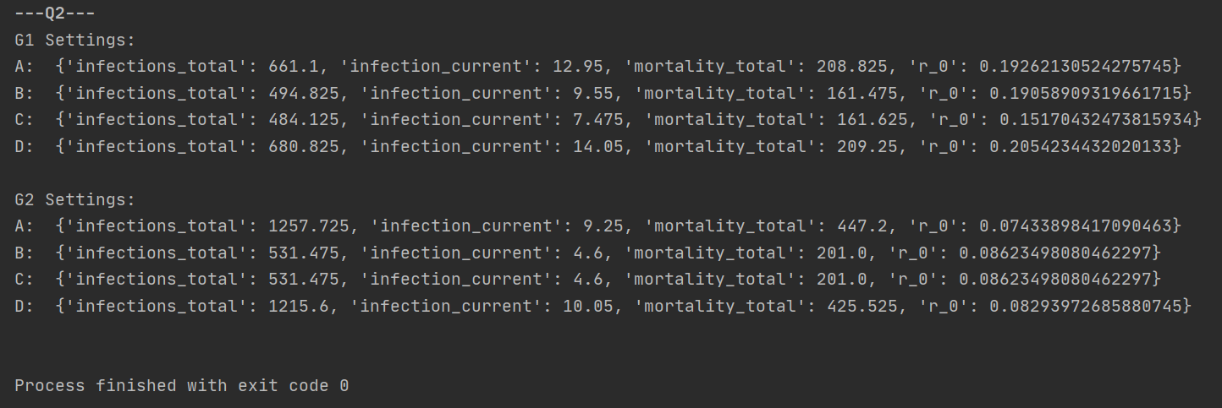

**C.**

1. G1: Betweenness, G2: Betweenness and Degree are tie
2. G1: Degree, G2: Betweenness and Degree are tie
3. G1: Degree, G2: Betweenness and Degree are tie

**D**.

**Random policy:** It will help a little to stop the epidemic, but in the long run it not be useful at all.

**Betweenness policy:** decrease all the result parameters, we could combine betweenness and degree policies, and get better results. **Big decrease on the R_0 parameter.**

**Degree policy:** decrease all the result parameters, we could combine betweenness and degree policies, and get better results.

**Mortality policy:** That policy will have no great effect on the network.

Assume that people with higher mortality like hood supposed to die with the infection and not speared the him. So, while we kept them alive, we kept just on them and make the other people more vulnerable.